**I want to work on github with the team. How do I do this?**

1. Create a github profile: <https://github.com/>
2. Download github desktop
3. Watch this video on github for non-programmers (it’s only 11 minutes): <https://www.youtube.com/watch?v=9XhbYHcaT9k>

**I want to make a contribution to a repo. How do I do this? Note: These instructions are specific to Github Desktop.** *If you have experience working with github and want to use an IDE, do your usual thing—there is no need for you to work from the desktop software.*

1. Make sure you have access to the git repo (**Ask Susie for access**—you will get an email invite to access the repo for the first time—she will need your username to add you)
2. Clone the git repo onto your desktop
   1. You can do this with github desktop software OR if you are an experienced programmer, do this your usual way
3. Fetch to refresh (yours should look like B)
   1. No (Last fetched….)



* 1. **Yes (Last fetched just now)**



1. Make a new branch
   1. Name this something that would make sense to someone other than you
      1. **Yes: “labeling_variables”**
      2. NOT “update code”

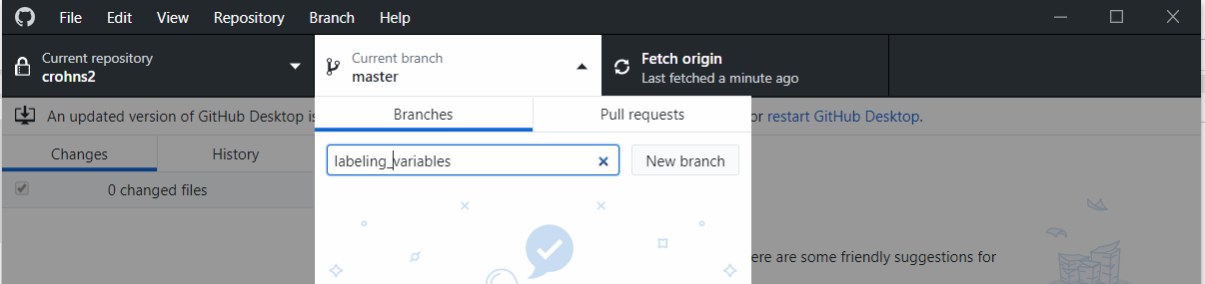

1. Your first branch will be from the master unless you are told differently. Feel free to make sub-branches off of your branches.
2. Commit often making comments about what you did. When you have completed a task, create a pull request. Say what you did so another team member can code review. Make a pull request for a specific task (not 200 lines of code). Some examples:
   1. Label all variables
   2. Format variables and checked that table1 macro works for this population
   3. Counted number of cd, uc, ibd encounters and output to a 1 record per person file

**I want to approve a pull request.**

1. Try watching the video above (<https://www.youtube.com/watch?v=9XhbYHcaT9k>) starting at around 4:30 to walk you through pull requests again. Pull requests are called PR in this video.
2. Find all the pull requests in your repo. They are listed in the tab Pull Requests.

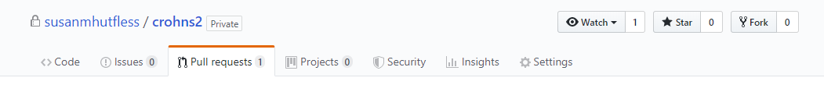

1. Click on the pull request that you want to review.

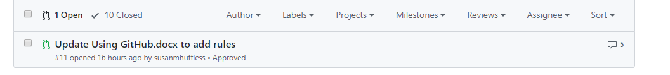

1. Merge the pull request

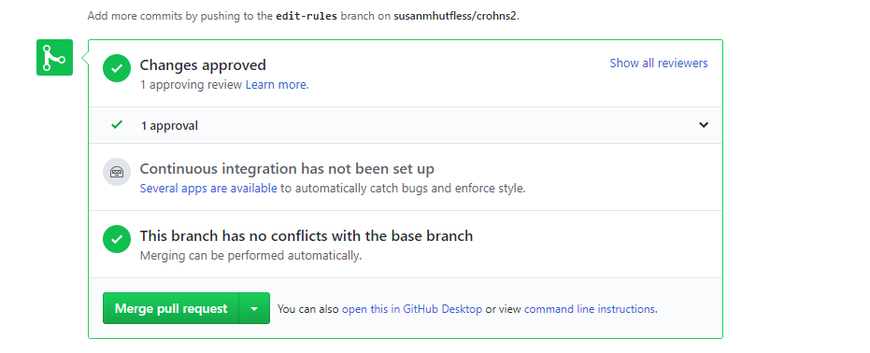

1. You can delete the branch when you are done.

**Rules of working on github**

* Fetch first
* Check your branch
* Never work on master
* Make a new branch for a new task
* Never put data on github repo
* Create pull requests on team repo
* 1 other person must review code before merging
  + A task is not “done” until someone else reviews/merges
* Commit often
* Never merge to master on the local machine
* Add descriptive comments to commits/pulls so it’s easy for the team to follow along